**DEVELOPMENT OF A MATERNITY CLINIC INFORMATION**

**MANAGEMENT SYSTEM**

**Design of Software, Systems, Product, and/or Processes**

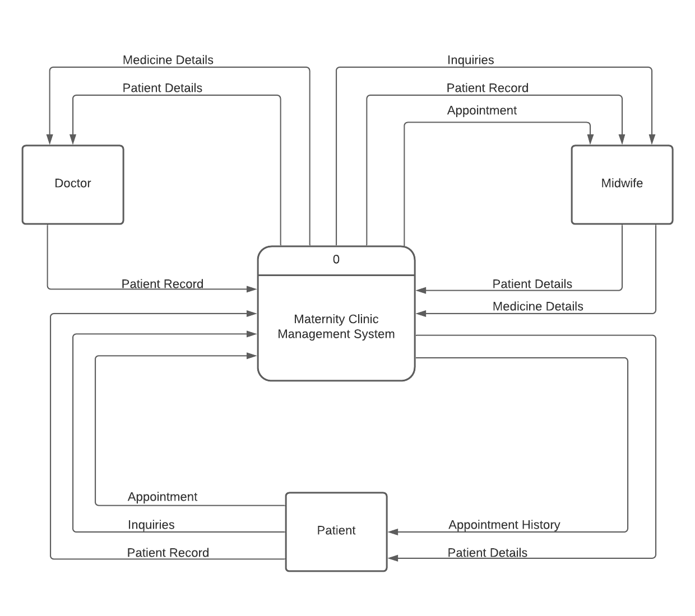

**Figure 3. Context Diagram**

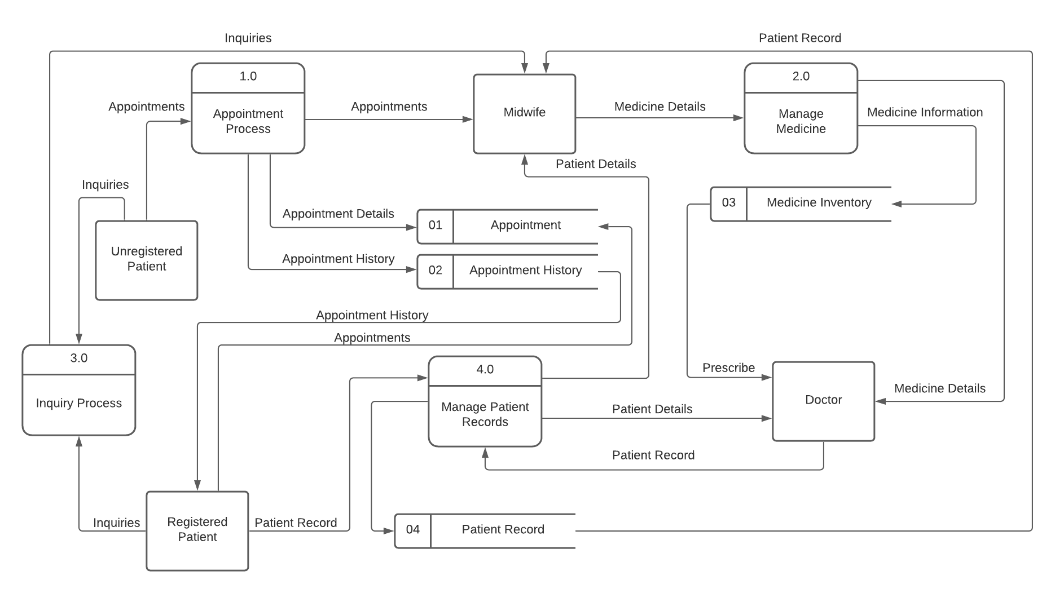

**Figure 4. Data Flow Diagram Level 1**

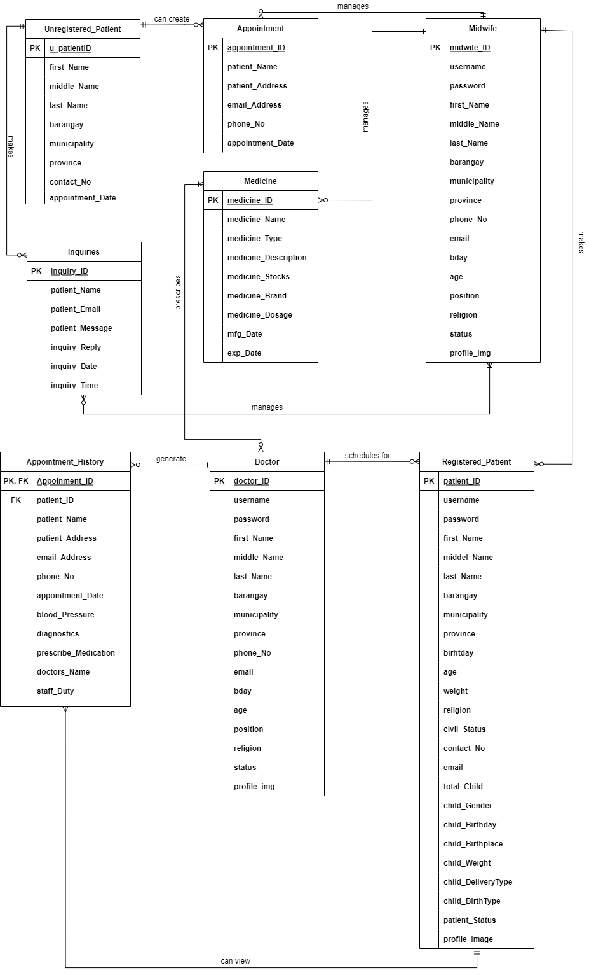

**Figure 5. Entity Relationship Diagram**

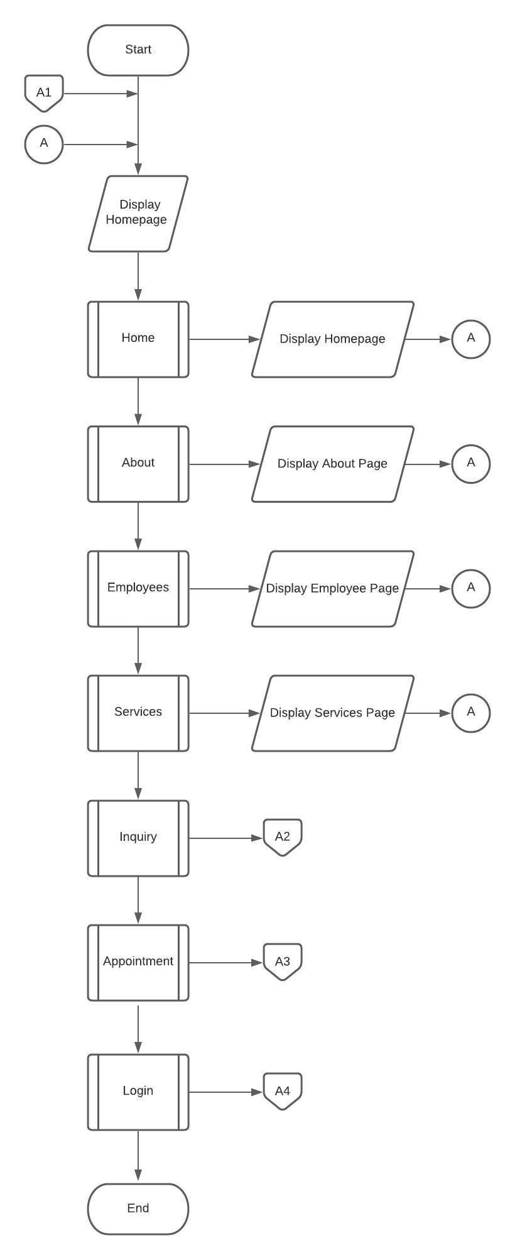

**Figure 6. Home Page System Flowchart**

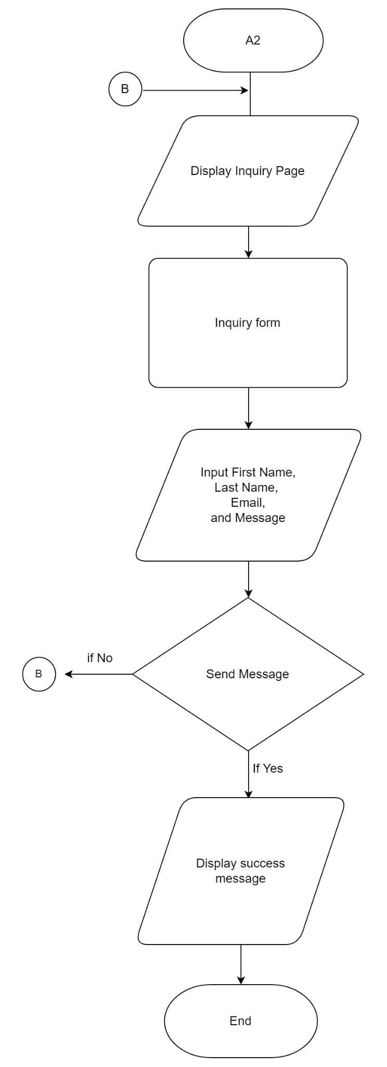

**Figure 7. Inquiry Page System Flowchart**

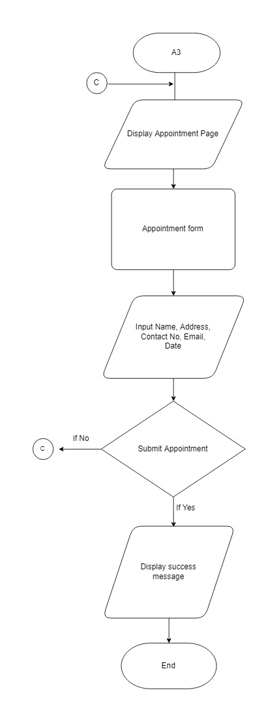

**Figure 8. Appointment Page System Flowchart**

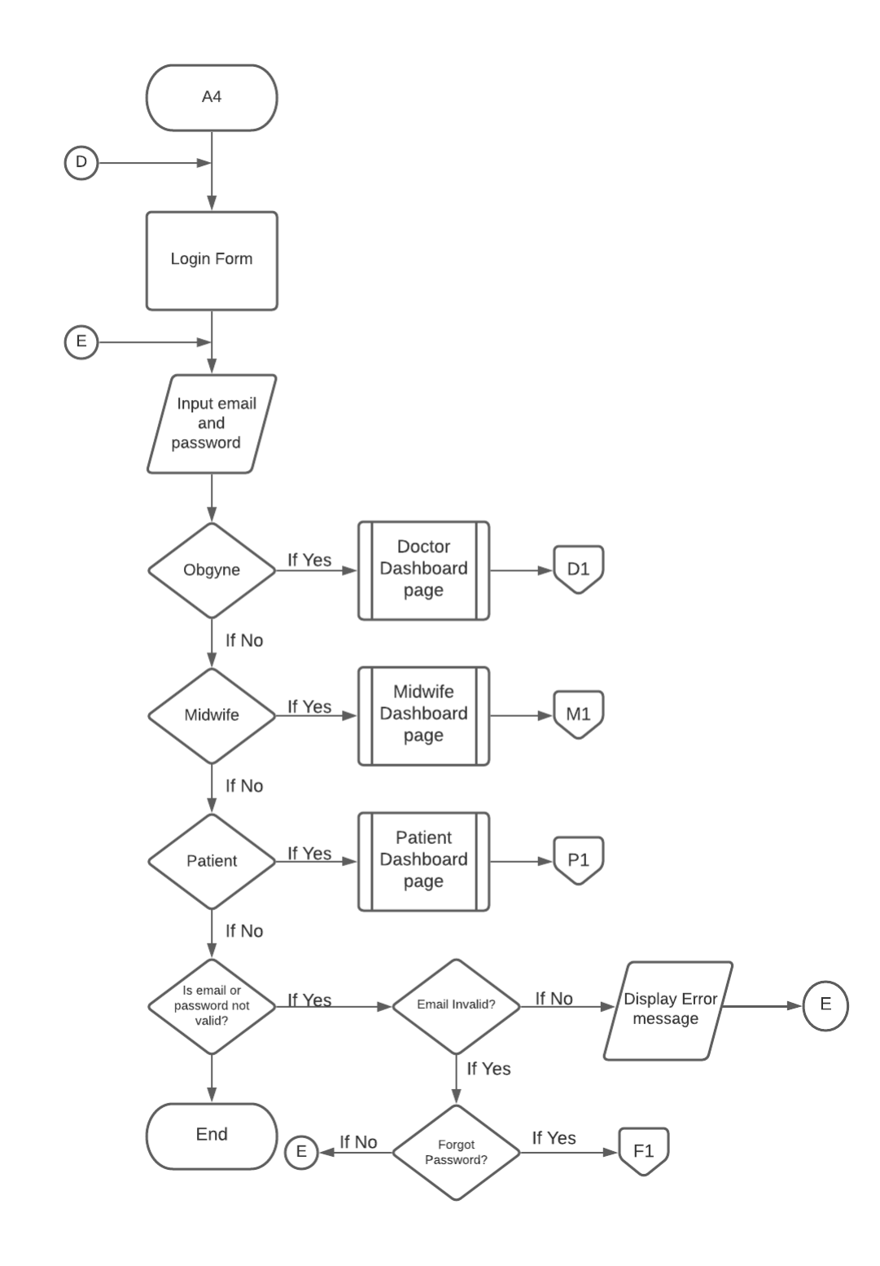

**Figure 9. Login Page System Flowchart**

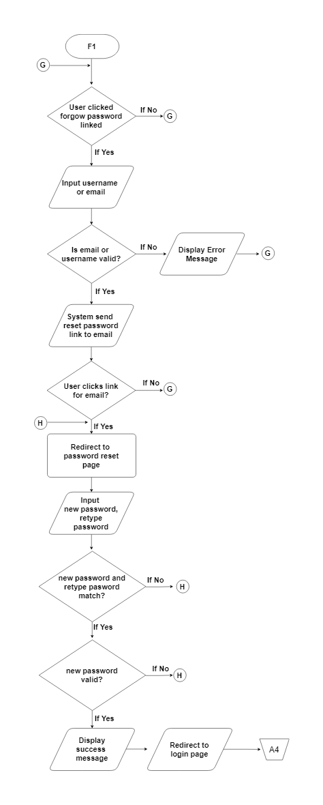

**Figure 10. Forgot Password Page System Flowchart**

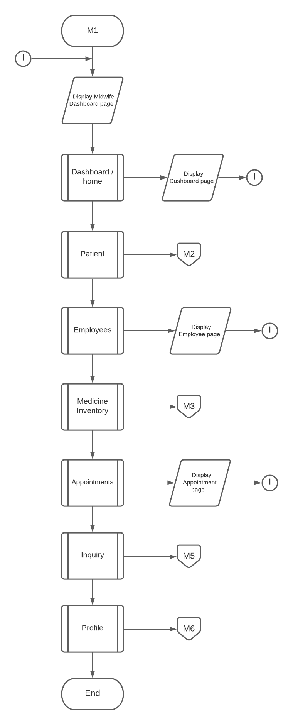

**Figure 11. Dashboard Page (Midwife) System Flowchart**

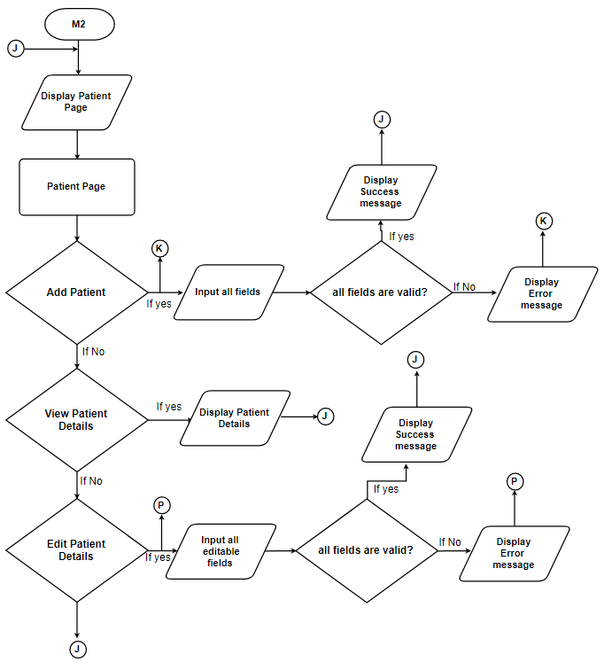

**Figure 12. Patient Page (Midwife) System Flowchart**

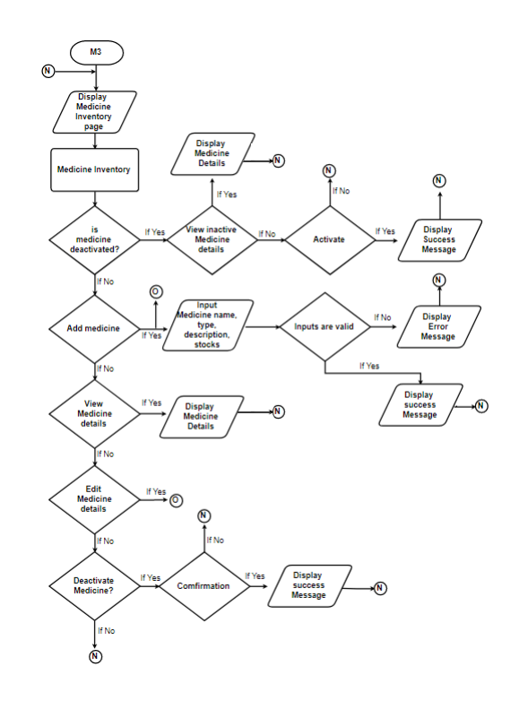

**Figure 13. Medicine Inventory Page (Midwife) System Flowchart**

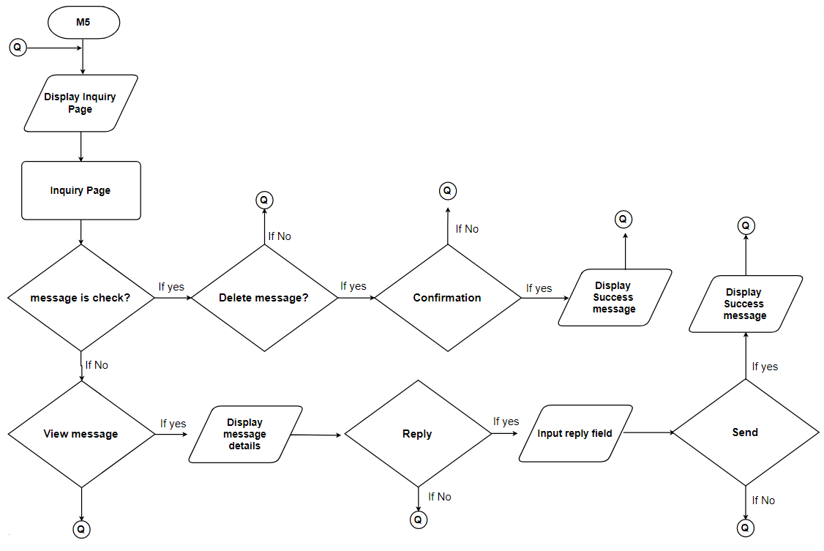

**Figure 14. Inquiry Page (Midwife) System Flowchart**

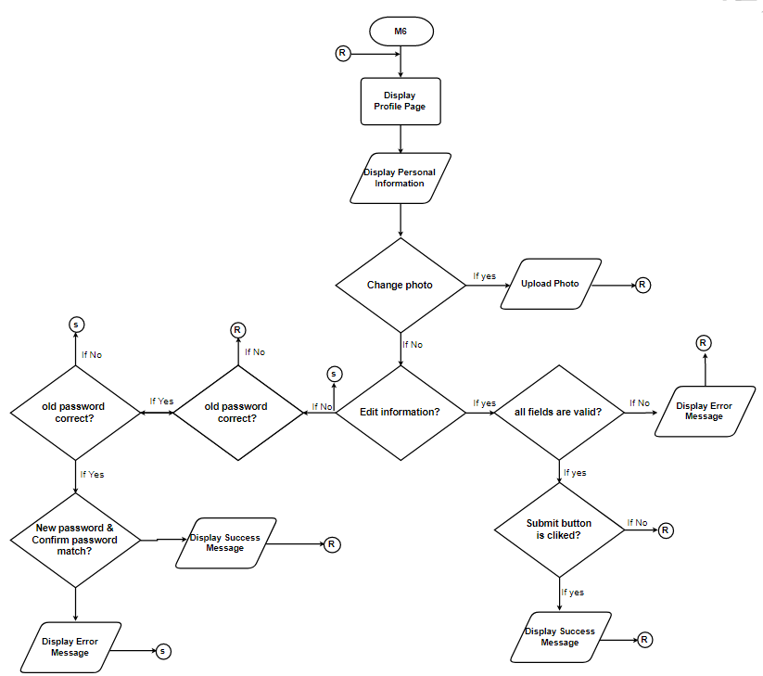

**Figure 15. Profile Page (All Account) System Flowchart**

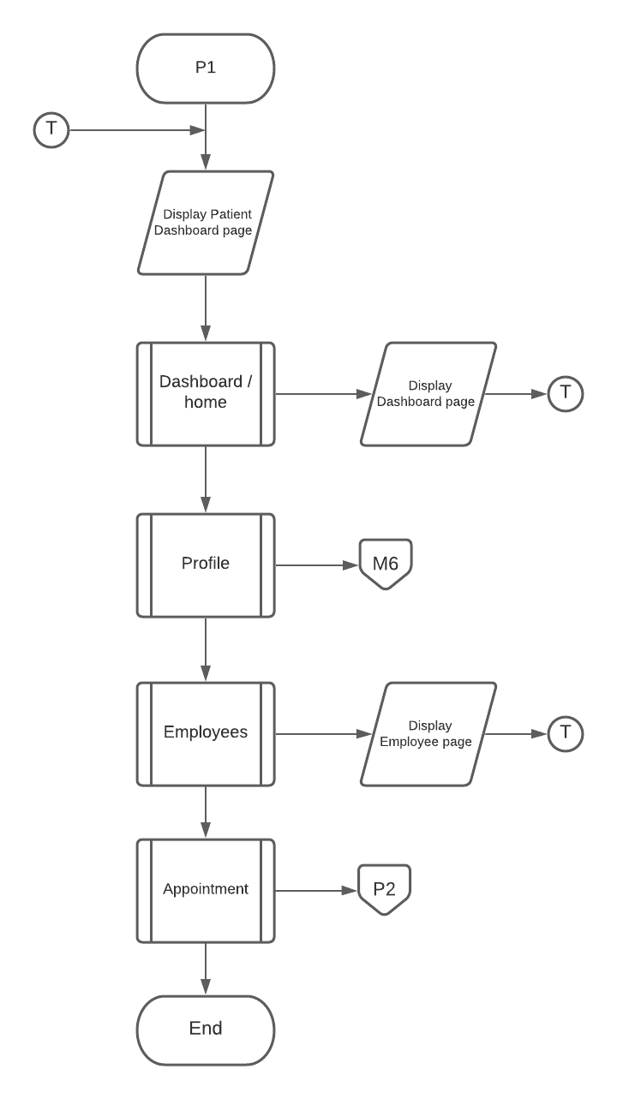

**Figure 16. Dashboard Page (Patient) System Flowchart**

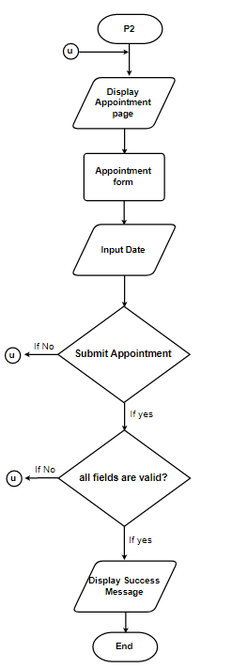

**Figure 17. Appointment Page (Patient) System Flowchart**

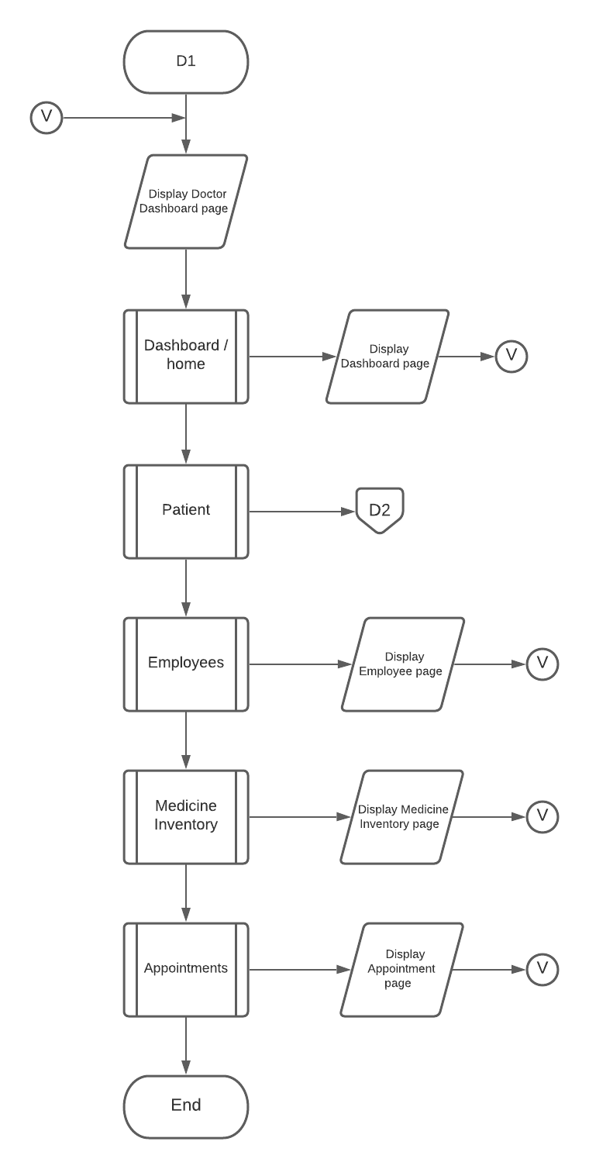

**Figure 18. Dashboard Page (Doctor) System Flowchart**

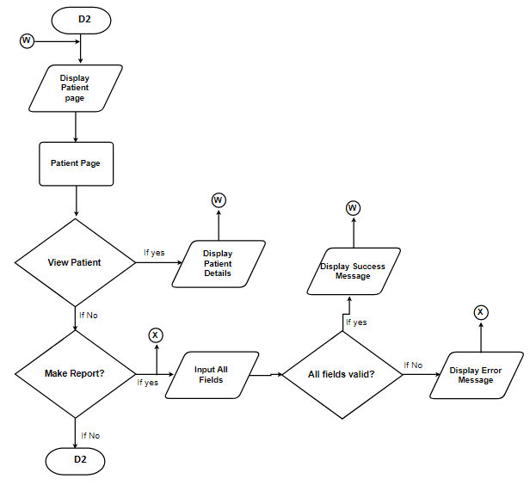

**Figure 19. Patient Page (Doctor) System Flowchart**

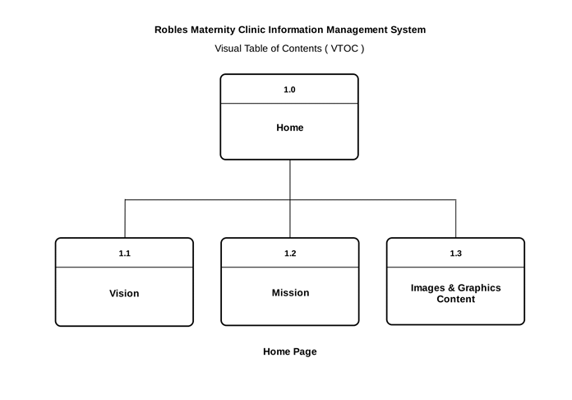 **Figure 20. Home Page Visual Table of Contents**

**Figure 21. About Page Visual Table of Contents**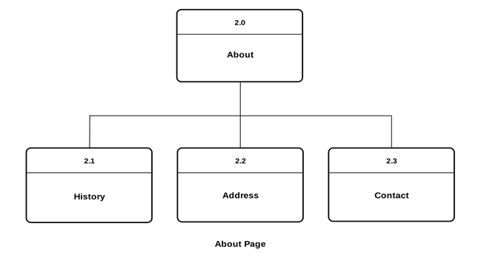

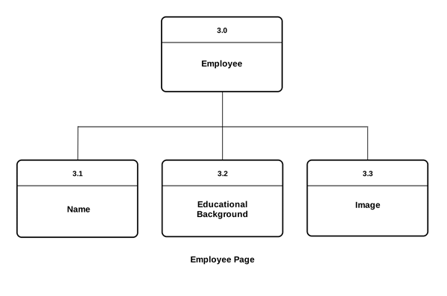

**Figure 22. Employee Page Visual Table of Contents**

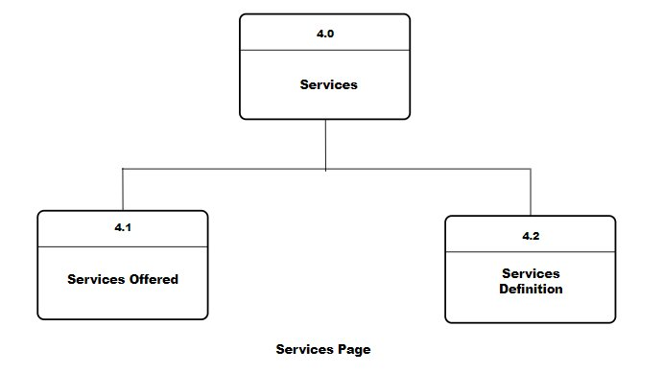

**Figure 23. Services Page Visual Table of Contents**

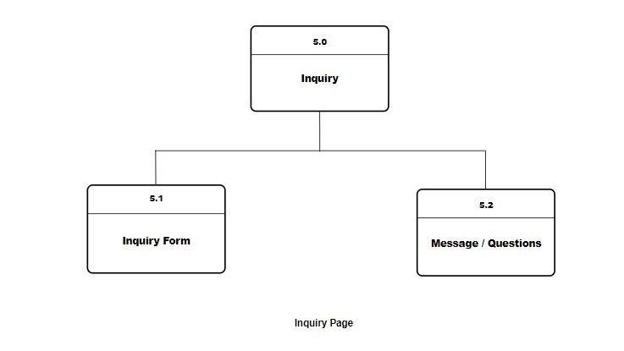

**Figure 24. Inquiry Page Visual Table of Contents**

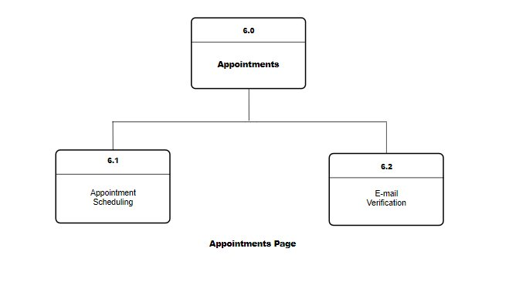

**Figure 25. Appointments Page Visual Table of Contents**

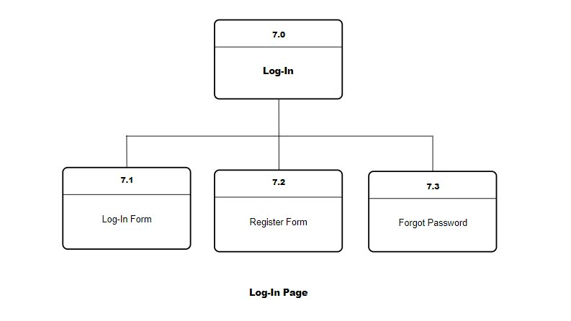

**Figure 26. Login Page Visual Table of Contents**

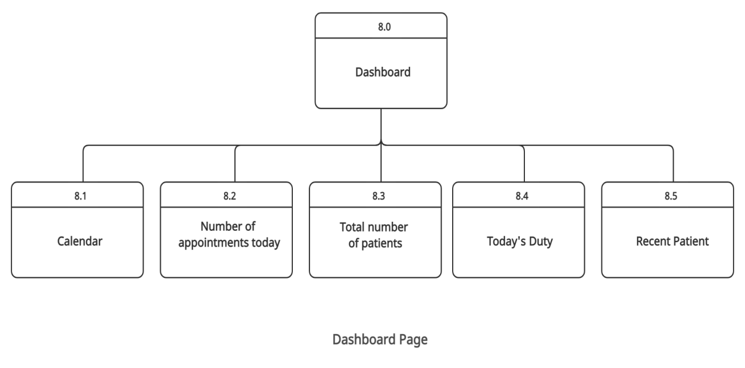

**Figure 27. (Midwife and Doctor) Dashboard Page Visual Table of Contents**

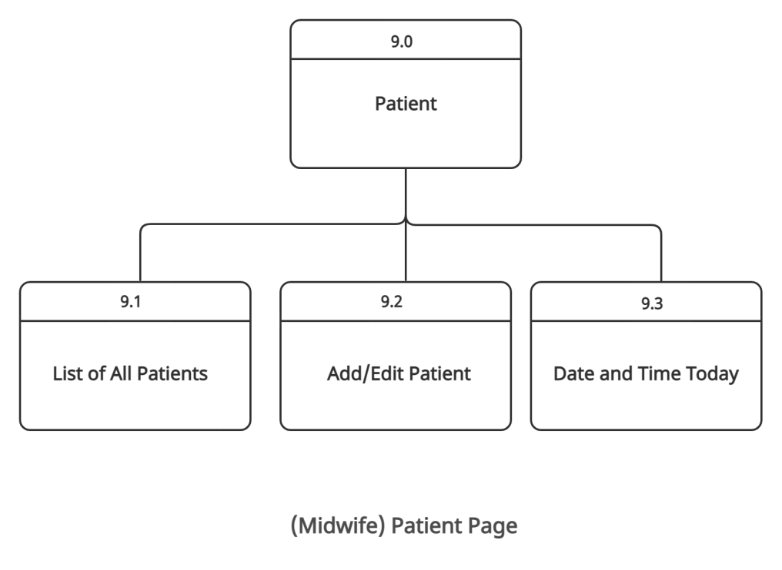

**Figure 28. (Midwife) Patient Page Visual Table of Contents**

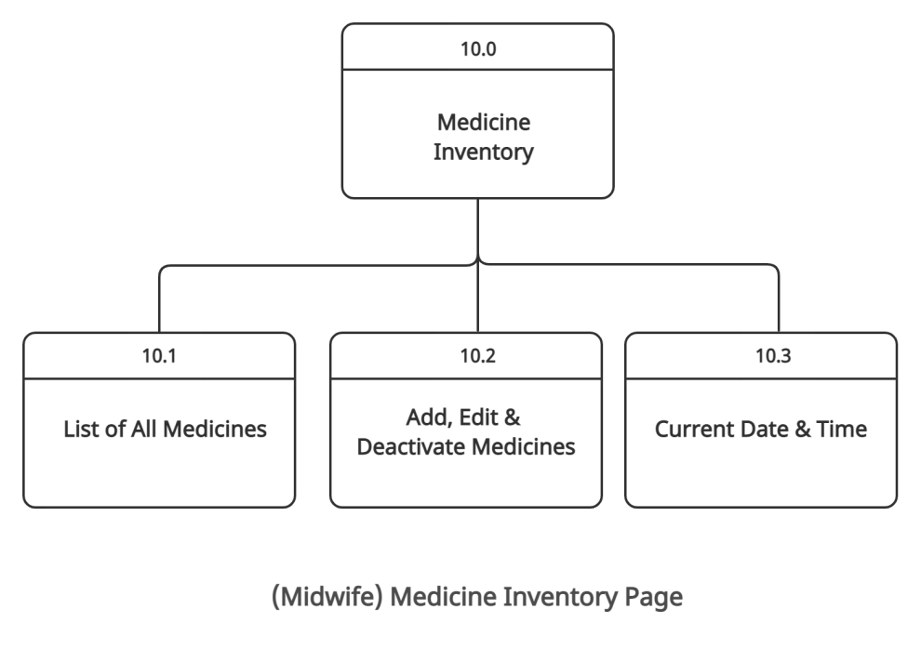

**Figure 29. (Midwife) Medicine Inventory Page Visual Table of Contents**

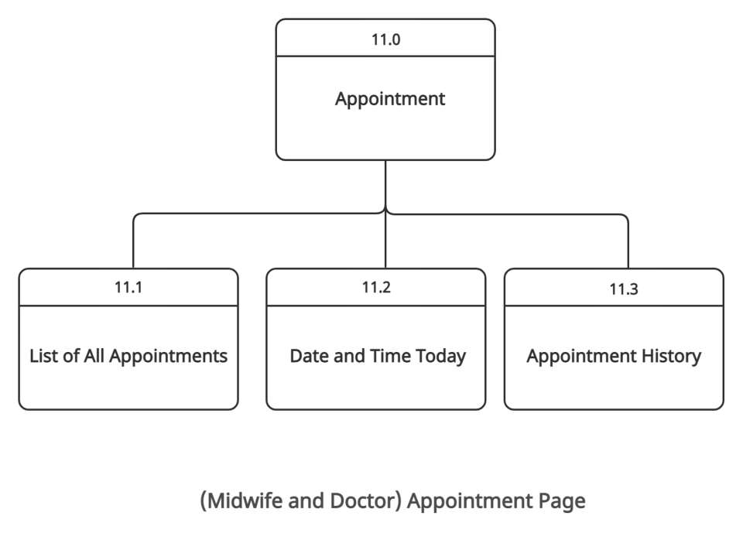

**Figure 30. (Midwife and Doctor) Appointment Page Visual Table of Contents**

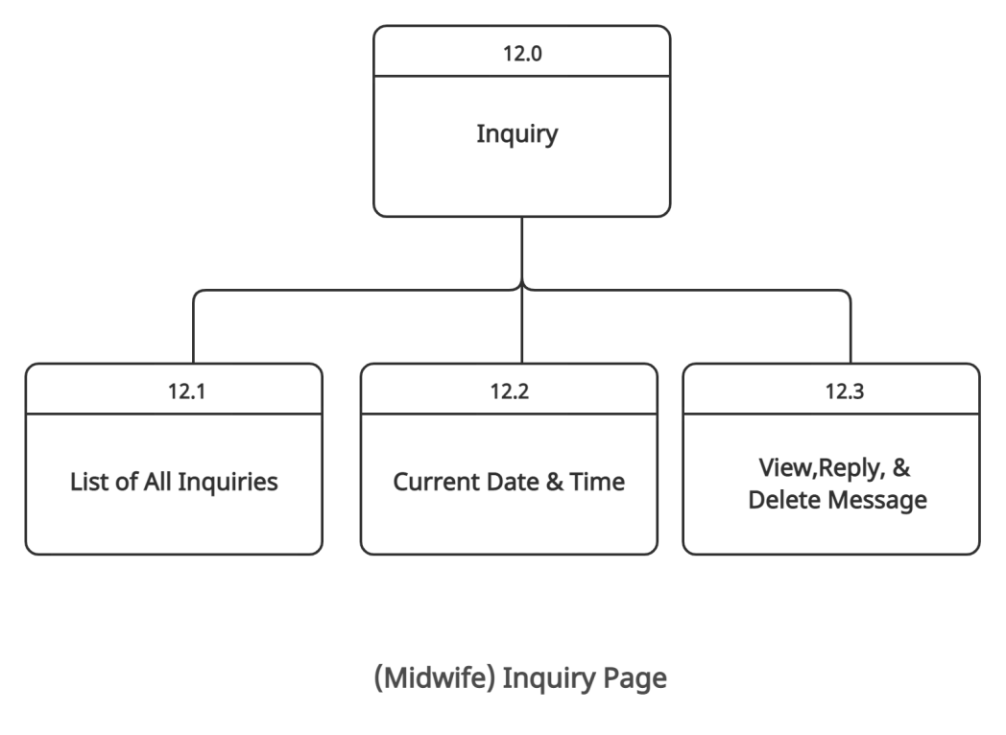

**Figure 31. (Midwife) Inquiry Page Visual Table of Contents**

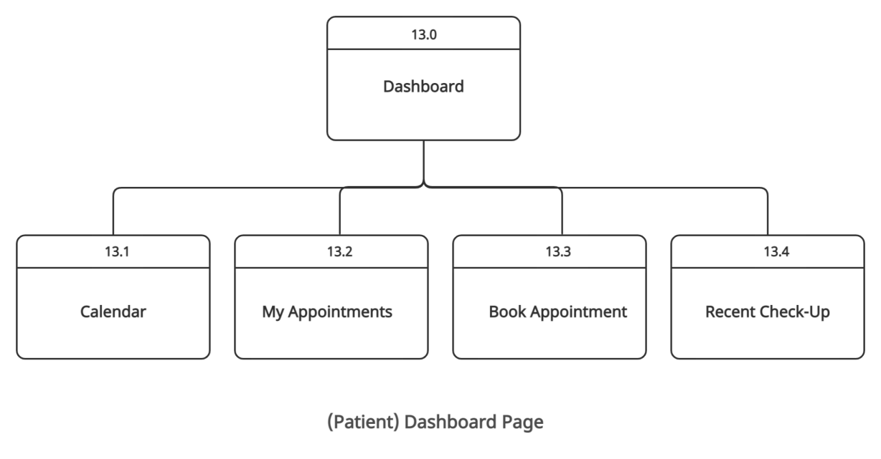

**Figure 32. (Patient) Dashboard Page Visual Table of Contents**

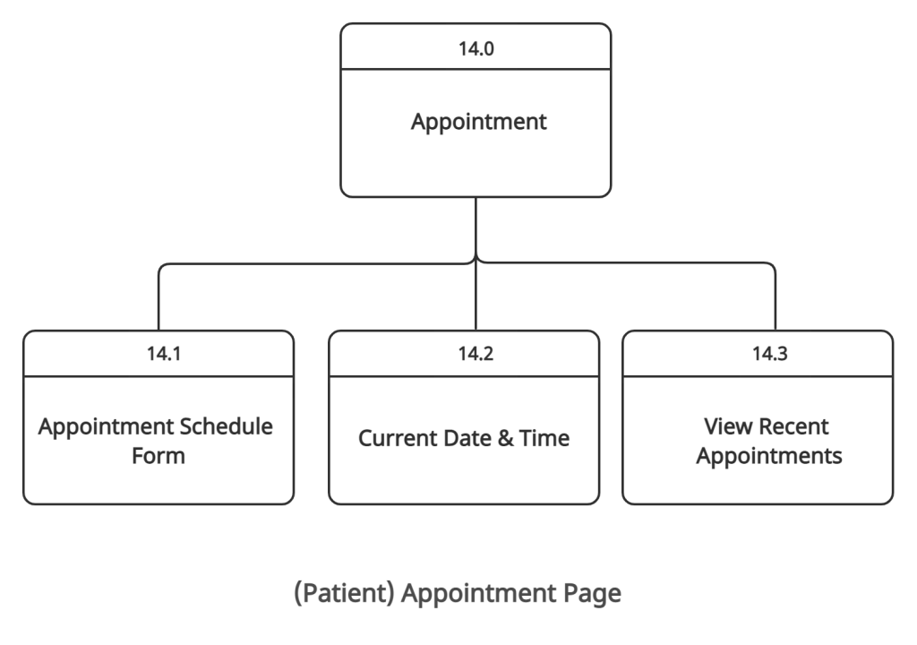

**Figure 33. (Patient) Appointment Page Visual Table of Contents**

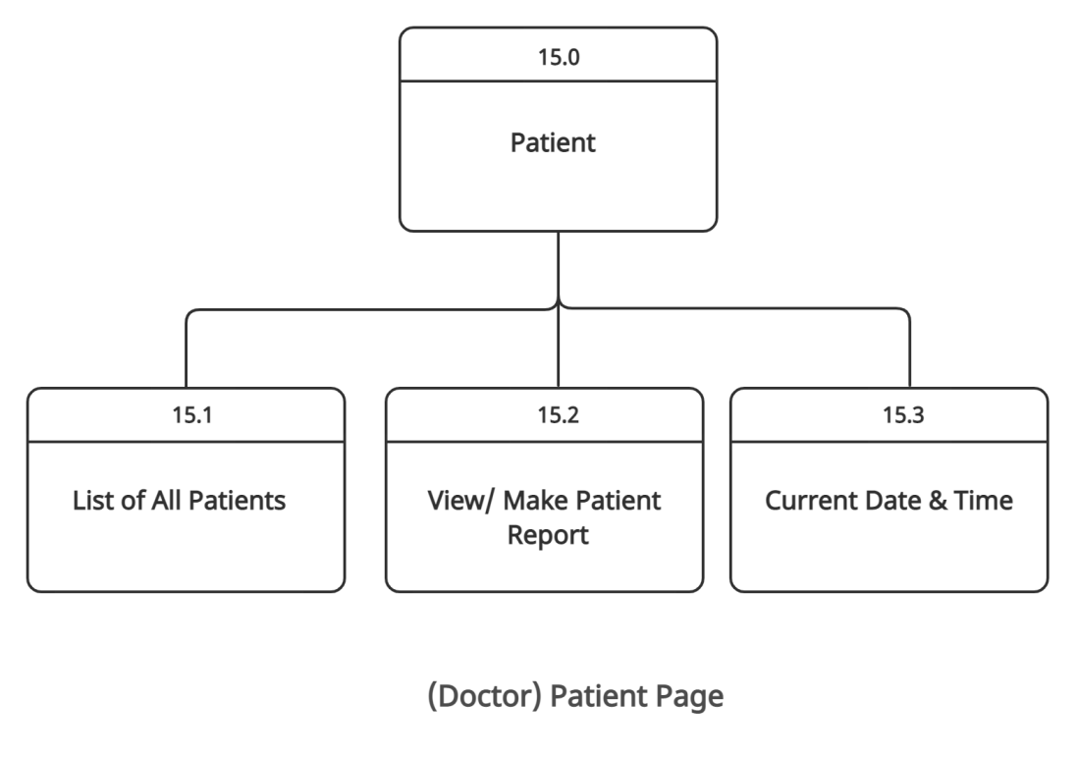

**Figure 34. (Doctor) Patient Page Visual Table of Contents**

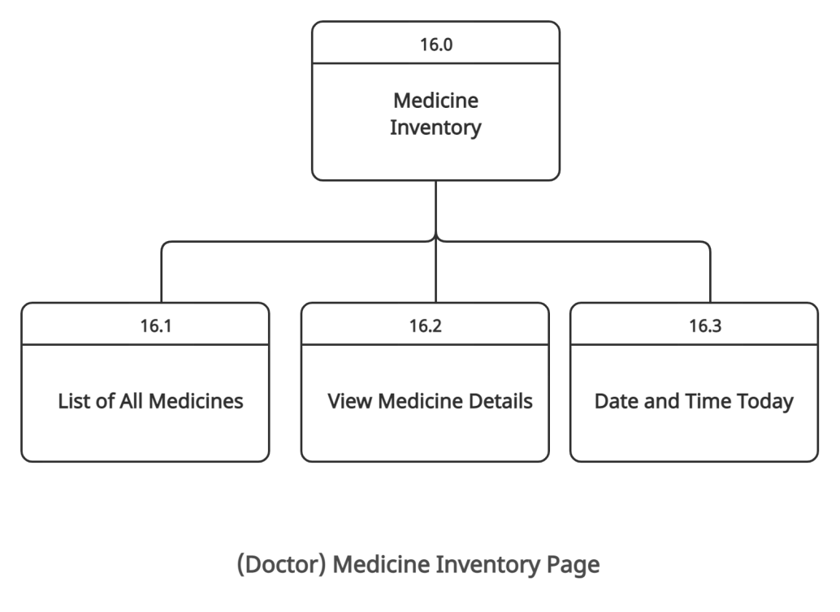

**Figure 35. (Doctor) Medicine Inventory Page Visual Table of Contents**

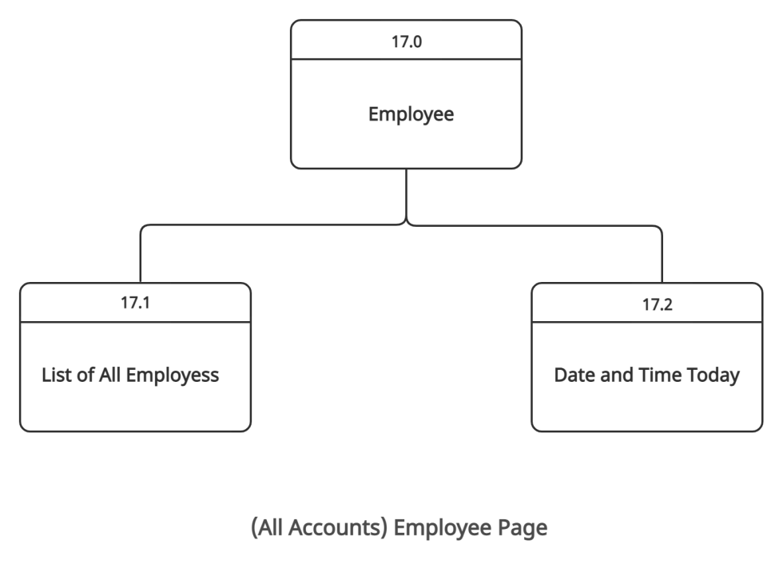

**Figure 36. (All Accounts) Employee Page Visual Table of Contents**

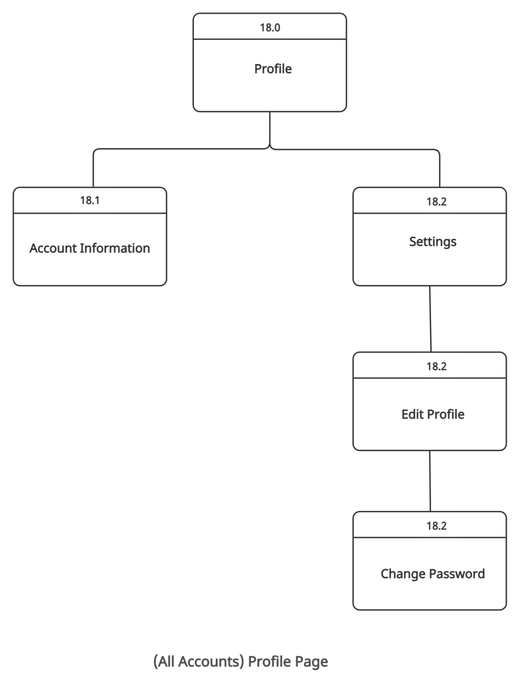

**Figure 37. (All Accounts) Profile Page Visual Table of Contents**